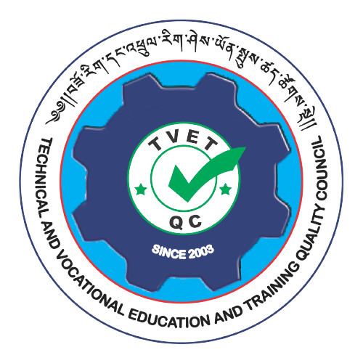

Technical and Vocational Education and Training (TVET) Quality Council
Bhutan Qualifications and Professionals Certification Authority (BQPCA)

Application for Approval to Develop a New TVET Qualifications at Level 1-5

Qualification Accreditation of TVET Qualifications

January 2024
Instructions:

This application sets out the requirements for developing a TVET qualification and describe the decision taken to approve an application for the TVET qualification to be accredited and qualification awarded to the learners. It is intended to be used by both the Training Providers and the TVET Quality Council as a Qualification Developer. This application applies to all TVET Qualifications in the BQF at Level 1-5.

The application for approval to develop a TVET qualification MUST meet the following information and evidence:
- A summary and rationale of the evidence to establish the need for a qualification
- The stakeholder profile for the qualification
- Completed qualification template containing:
- Qualification/Occupation title, type, level and credit value
- A statement of strategic purpose
- Stakeholder profile and reason of their involvement
- A qualification outcome statement including education and employment pathways

- Organization and Contact Person Details
Organization/Institute Name:
Address (location/place): | Type of Organization: (tick √)  - Government  - Private  - Corporate  - NGO  - Others_______________________
Telephone No: | Email Address:
Key Contact Person:
Job Title:
Email Address: | Contact No (Mobile):

- Occupation Title and Type of Qualification
Note: Specify the Occupation and tick the type of qualification you wish to offer
Occupation Title:
Note: Please explain concisely and accurately the purpose of the qualification to learners, employers/industry and others, indicate the overall intent of the qualification including entry requirements

Note: Tick relevant certificate level and credit value as per BQF (refer table 4)
BQF Level | Qualification Type | Credit value | Tick √
5 | Advanced Diploma | 240
4 | Diploma | 240
3 | Certificate 3 | 40
2 | Certificate 2 | 40
1 | Certificate 1 | 40

- Strategic Purpose Statement/Need to Develop a Qualification (TVET Qualification)
Guidance: The comprehensive needs analysis that identifies and confirms the distinct need in Bhutan for the Qualification (TVET). The summary report should include a brief profile/overview of industry which addresses workforce requirements including the size and demographics of the workforce, growth, turnover. Current and future skill needs including anticipated changes in work practice and technology. Characteristics of the learners, including low participation and barriers to access. Current qualifications if any. The rationale of the distinct and genuine needs for the qualification at the National Qualification Level and/in terms of specific sector-industry or community needs.
- Qualification outcome statement
Guidance: The outcome statement will be interim but needs to clearly reflect the needs identified and the level of the qualification. The outcome includes what the graduate of the qualification is expected to do, be and know, as a result of the learning. It should indicate range of functions/scope of practice, the graduate is able to perform. It should also include education and employment pathways, contribution to the industry, communities resulting from achievement of the qualification.
- Graduate Profile: (describe what a person awarded the qualification must be able to do, be and know)
The Graduate of this qualification will be able to: (use action verb, subject and context)

- Education pathways (Describe further learning opportunities a graduate can undertake)

- Employment pathways (describe areas in which the graduate may be qualified to work/contribution they may make to the industry/community

- Stakeholder Profile
List the name of stakeholders (employers/industry/associations etc. with an interest or stake in the outcome of a qualification are considered to be stakeholders)
Sl.no | Name of stakeholder | Reason for their involvement
1
2
3
4
5
6
7
8
9
10
11
12

Official Use for Qualification Developer (TVET Quality Council)

Approval to develop a qualification
Note: The decision to approve a qualification for the development of a qualification should meet the defined criteria for both quality and sufficiency as specified below:
SL | Evidence | Criteria | Tick (√)
1 | Sufficient evidence  Application approved | All of the following  - Good evidence that the occupation and the qualification address the relevant needs of learner, industry and communities  - No significant gap or weaknesses in the application or evidence  - Stakeholders are complete and well defined
2 | Insufficient Evidence  Application denied | Any of the following  - The nature, quality of the evidence insufficiently addresses the relevant needs of learners, industry, communities  - the application and the evidence has some significant gaps or weaknesses  - Stakeholder are not well identified and complete
Feedback/Comments (if any)

Application reviewed by:

1.

2.

3.
Date:
Endorsed by:

__________________ _________________
Head Director
TVET Quality Council. BQPCA
Date:

